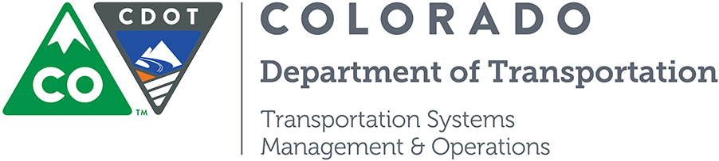

Update on the DR 3447 – the new Colorado Crash Report Form

May 2019
Over the last 10 years, fatalities in Colorado have been trending upward reaching 630 fatalities in 2018. To bring the number of traffic fatalities down accurate and timely crash data is critical for developing data driven strategies for reducing fatalities on Colorado’s roadways.
Deployment of the DR3447 Crash Report Form
The DR2447 crash report will soon be replaced with the new DR3447. The Colorado crash form has been updated to provide better data regarding the crashes that occur and better adapted to electronic reporting (which is easier to fill out for the officers investigating crashes).
The Statewide Traffic Records Advisory Committee (STRAC) was responsible for the revisions to the DR3447 and is here to inform you about how you can get prepared for the new form.
Where to Find the Details
You’ll find the following on the STRAC website (https://www.codot.gov/about/committees/strac)
- Information on the DR3447, including a PDF of the form, the associated data model, and the Investigating Officer’s Manual.
- A video that highlights the major changes from the DR 2447 to the DR 3447. Individual chapters can be found at the following links:
- Chapter 1: Intro (https://youtu.be/je1ZY2buXJ4)
- Chapter 2: How Crash Data Helps (https://youtu.be/dDr_n3VP7Bg)
- Chapter 3: Overview of the DR3447 (https://youtu.be/ehdELxm2hIM)
- Chapter 4: Crash Page (https://youtu.be/WaP1o5Mv474)
- Chapter 5: Narrative, Diagram, and Damaged Items Page (
https://youtu.be/qb-wYrBXYgc)
- Chapter 6: Motorized Traffic Unit/ Occupants Pages (https://youtu.be/qlNJjUEg3WE)
- Chapter 7: Traffic Unit/ Non-motorist Page (https://youtu.be/_a3Ehbx5DfE)
- Chapter 8: Thank you/ Contact Information (https://youtu.be/WjxUKDFNFgs)

Timeline of the Rollout

The statewide rollout of the DR3447 will include the following milestones:
- Colorado Department of Revenue (CDOR) will upgrade the crash report repository for the DR3447. When that step is complete, CDOR will be able to accept DR3447 on paper (or PDF).
- CDOR will develop the electronic submittal interface. When that step is complete, CDOR will publish the interface specifications.
- Once the agencies have adapted their RMS systems to the new form, they will be able to test the submittal process to CDOR. Once the testing has successfully completed, the agencies can submit DR3447 crash reports electronically.
- NOTE: The DR 2447 will still be accepted for approximately one year after deployment of the DR 3447 submittal interface (step 2 above).

How to Prepare Now
While dates for the key milestones have not yet been determined (they will be updated on the STRAC website as soon as they are known), agencies can already start preparing for the transition to the DR3447:
- For agencies that collect crash report data on paper, they can print the DR 3447 crash reporting form. When the timeline becomes clearer when DRIVES will be online and able to accept the DR 3447 the STRAC will indicate when agencies can start using the paper version of the DR 3447 for crash reporting.
- For agencies collecting crash report data electronically, the RMS and/or Crash Reporting module will require modifications for the new form. Discuss with your RMS vendors now about the transition to the DR 3447, specifically covering:
  - Collecting the data to populate the modified form.
  - Printing out the data in the standard format.
  - Submitting the electronic form data to CDOR.
  - Determining if maintenance contracts cover the development of the DR 3447 or if a new contract is needed.
- Plan and obtain funding as needed for the transition.
- Update the agency-specific training and operations materials to reflect the new form.
- In the coming months DOR will need a diverse pool of law enforcement agencies to test the implementation of the DR 3447 into the DRIVES system. Any agency that would like to be involved in the testing, please contact us at: dot_hq_strac@state.co.us.

If there is additional information (or deliverables such as an interface specification and test harness) that law enforcement agencies or your RMS vendors need to assist with the transition you may also contact STRAC at: dot_hq_strac@state.co.us.
Safety analysts should prepare for updating analysis tools, standard reports, etc. to work with the new data format and to take advantage of the expanded data elements that will be available.
Funding Support
Agencies that want to start collecting and submitting crash data may be eligible for funding. STRAC funding is available to assist agencies with projects such as acquiring or implementing e-crash or e-citation that includes electronic submittal of these records to DOR.
Agencies already collecting and submitting electronically may be eligible for funding to support their transition to the DR3447.
More information is available the STRAC website (https://www.codot.gov/about/committees/strac)
How to Stay Up-to-Date
- You can find up-to-date information on the crash form update process, templates of the DR 3447 crash form, updated officer manual and DR 3447 data model at the STRAC website (https://www.codot.gov/about/committees/strac)
- We will periodically send information out through the same channels as this newsletter. If you want to be added to the mailing list, let us know by emailing STRAC at: dot_hq_strac@state.co.us.

