Transporting Students With Special Needs for School Bus Drivers
NHTSA School Bus Driver In-Service Safety Series

Learning Objectives
At the completion of this module, participants will be able to:
- Describe what the school bus driver/attendant of students with special needs is expected to do and what is outside that person’s responsibility.
- State what the school bus driver/attendant of students with special needs should know about each student he/she transports.
- State the kinds of disabilities a student with special needs might have.
- State the types of behavior a student with special needs might display.
- State who is part of the team working for the student with special needs.
- Describe how and what to communicate to:
- Other helpers (monitors, aides, occupational/physical therapists)
- Supervisor
- Parent or caregiver
- Student
- Explain what to do in unexpected situations.
- List the types of equipment a student with special needs might require during transport.
- State proper guidelines for storing equipment.
- Explain how to handle service and guide dogs.
- Discuss how to handle equipment in adverse weather conditions.
- Describe the proper loading and unloading process, including what to do and who should do it.
- Describe how to correctly operate the lift.
- Describe how to correctly secure both the wheelchair and restrain the student in the wheel chair while on the school bus.
- State the necessary elements of a seating plan.
- State the types of emergencies the school bus driver/attendant can expect.
- List the elements of an emergency evacuation plan.
- Describe the process for handling an emergency.

Time Required
5 hours, 20 minutes without practice sessions

Training Methods
- Participative lecture
- Guided discussion

Training Materials
- PowerPoint slides and projection system
- Flipchart and markers
- Handouts and Job Aids: The School Bus Driver/Attendant of the Student with Special Needs, Job Aid #1; Disabilities, Behaviors, and the School Bus Driver, Job Aid #2; Team Communications, Job Aid #3; Wheelchair Standard, Job Aid #4; Equipment and Assistive Devices in a School Bus, Job Aid #5; Loading and Unloading, Job Aid #6; The Wheelchair Lift, Job Aid #7; Emergency Situations, Job Aid #8; Local policies and procedures; IEP Form.

Lesson Plan | Instructor Notes
I. Introduction and Overview  Say that you want to welcome everyone to the course. Introduce yourself. | 35 minutes  Show Slide 1.
Explain that the purpose of the module is to review the procedures for drivers/attendants who regularly transport students with special needs.  Say that this course isn’t detailed enough to train a new school bus driver/attendant of students with special needs. | Show Slide 2.
Tell drivers that the information presented in this module is useful for all transportation personnel. Since the trend now is to integrate students with a variety of special needs with students on regular bus routes, you may need this information at some point.
Explain that, in particular, this module focuses on students with special physical needs. For example:  - A student who uses braces, a wheelchair, a walker, etc.  - A student who has recently had surgery  - A student who needs a child safety restraint system | Show Slide 3. 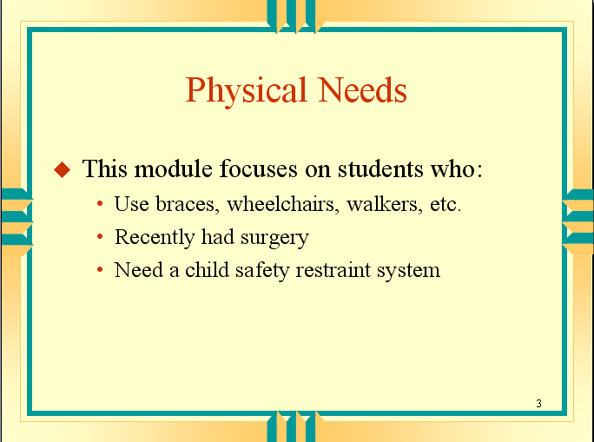
Say that we will talk about what kinds of equipment you might encounter and how to transport students using that equipment. First, let’s talk about working with students with special needs.

Working With Special Needs Students
Say that working with special needs students is different than working with other students.
- The policies may be the same:
- For example, there are standards for acceptable behavior that apply to all students
- But the abilities may be very different for students with special needs.
Ask: | Conduct discussion.  List areas that you have to handle differently. Examples might be discipline, loading and unloading, emergencies, bad weather, communicating with caregivers.
  What things do you have to handle differently when you are working with students with special needs?
Explain that, in addition to being aware that you will need to handle many situations differently, there are certain things you should know about each of the students on your school bus.
- You should know about the characteristics of the disability.
- You need to know medical specifics relevant to transportation.
- It may be a chronic disease, a congenital condition, a degenerative condition, or a temporary situation due to surgery/injury.
- What matters is the impact of transportation.
- What you do need to know is what impact that disability will have on your job of transporting the student.
- In normal situations: How does the student need to be transported?
- In emergencies: What can and can’t the student do without help?
- You should know what equipment they use.  - You need to be able to handle that equipment properly and safely in accordance with manufacturers’ guidelines.  - You should know what transportation recommendations are included in the Individualized Education Program or IEP. | Show Slide 4.
Ask: | Distribute Job Aid #1, The School Bus Driver/Attendant of the Student with Special Needs. Review it with participants.  The IDEA can be found at 34 CFR 300 and on the Web site www.access.gpo.gov/nara/cfr/  “Free and appropriate public education” is also known as FAPE.
  How many of you have heard of the Individuals with Disabilities Education Act?
Say that the Individuals with Disabilities Education Act, or IDEA, guarantees students with special needs a free and appropriate public education
- Special education must be designed to meet each student’s unique educational needs.
- Those unique special educational needs and how they will be addressed are described in the student’s individual educational plan or IEP.
Individual Educational Plan (IEP)  Say that one of the things that the IEP covers is transportation.  Explain that the IEP process has 2 parts.  - The IEP Meeting  - At this meeting parents and school personnel jointly make decisions about a student’s special educational needs. | Guidelines for when a school district should have transportation personnel in attendance at IEP meetings are included in Transporting Students with Disabilities developed by the Special Needs Committee of the National Association for Pupil Transportation, 1996.

Lesson Plan | Instructor Notes
- The IEP team includes:  - Teachers (1 regular and 1 special education, as appropriate)  - School administrator  - Appropriate related services personnel who work with the student  - Medical: school nurse, physical or occupational therapists, doctor  - Social service representative  - Transportation personnel  - Parents or caregivers  - The student, if appropriate  - Transition services personnel | Depending on the policy and procedures in your school district, there may be a discussion here of whether or not transportation is or should be included in IEP meetings. If transportation is not represented, there may be frustration over the lack of communication and its effects.
- The IEP  - The IEP is a written record of the decisions agreed upon at the IEP meeting  - The IEP defines the resources and services to be provided to the student, including when and how long they will be provided.  - The IEP addresses transportation issues such as:  - Type of transportation needed  - What equipment the student uses that must be transported  - Whether the student needs an attendant  - Transportation restrictions (for example, a maximum riding time)  - You can provide input to the IEP team about transportation issues. | Distribute copies of the IEP form used in your state. Point out what subjects are discussed at the IEP meeting, including “Related Services” such as transportation.  Refer participants to the section of the handout that is an excerpt of the 1995 National Standards for School Transportation. Tell participants that you won’t cover the section in depth but information is there for participants to refer to when and if they need it.  Tell participants who they would talk to at the school to find out about a student’s IEP.
Ask: | For detailed questions, refer to the appropriate person at the school or school district.
  Are there any questions about the IEP or what the school bus driver/attendant should know about each student?
Say that you will now go over some general guidelines that will help the drivers of students with special needs.  - Know about your students and what they need.  - Know where important information is located  - The route  - Manufacturer’s instructions for lifts and securement systems  - The seating plan  - Emergency information  - DNR (Do Not Resuscitate) orders  - Special medical information  - Emergency equipment (fire extinguishers, first aid kit, etc.)  - Exercise universal precautions. At all times you should have:  - A body fluid clean-up kit  - Non-latex gloves (for students with latex allergy)  - Don’t use a lift without another experienced driver or aide until you feel comfortable. | Show Slide 5.  Only carry non-latex gloves. We will never know every student that may have an allergy to latex. Staff may also have an allergy to latex and not be aware of it.
- Only do what is within your technical expertise.  - There are lots of other resources to assist you.  - Don’t rush; take your time.  - When in doubt, ask. | Emphasize that “asking” is not a reflection of a school bus driver’s incompetence. Rather it is an indication that the school driver wants to do the best that he/she can.
Explain that it is important to remember that you are first the school bus/driver attendant.
- You should know what your school district expects of you.
- You are responsible for:
- Safely driving the school bus
- A pre-trip inspection of the school bus
- Loading and unloading
- Safely handling and maneuvering the student and his or her equipment
- Loading wheelchairs using a lift
- Securing wheelchairs and other equipment
- Restraining the student
- Maintaining the equipment on the school bus used to secure the student and his or her equipment
- A post-trip inspection of the school bus
- Communicating with parents/caregivers and teachers about situations that might affect the safe transportation of the student
Review local policies and procedures about the role of the school bus driver/attendant.  Ask: | If not, proceed to the next section.
  Are there any questions before we move on to the types of equipment and behaviors you might encounter?
II. Types of Disabilities and Behaviors  Explain that you have said that drivers need to know enough about a student’s disability to know what impact it will have on transporting the student.  Say that in this section you are going to talk about:  - The kinds of disabilities a student with special needs might have  - The types of behaviors a student with special needs might display | 25 minutes  Show Slide 6.
Say that many of the students transported have physical disabilities and require specialized equipment.
- Later there will be a discussion of how to safely transport the student and his or her equipment.
Tell participants that, right now, the focus will be on some of the other things to take into consideration when transporting students with special needs.  Say that, in addition to their physical involvement, for some students there may also be communication barriers.  - Some students may have cognitive limitations that affect their ability to understand your directions  - They don’t know what you mean because they have a problem understanding language.  - Some students may have disabilities that affect your ability to communicate with them and their ability to communicate with you | Show Slide 7.  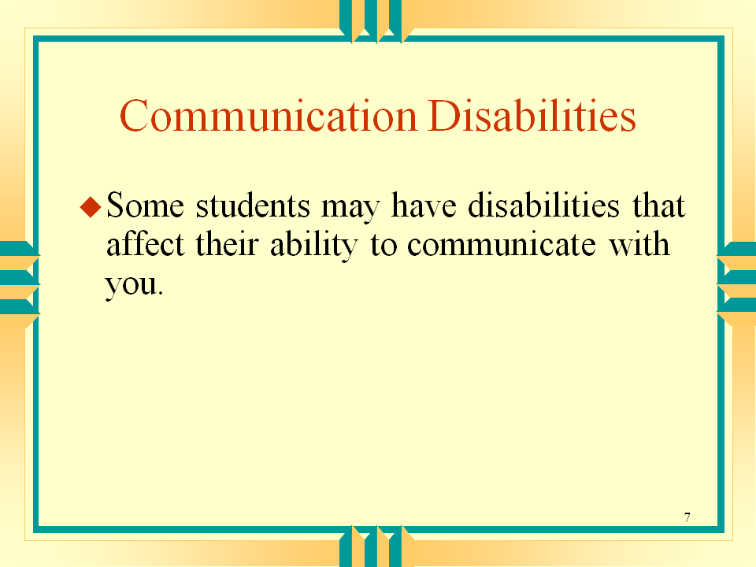
Ask: | Record responses on a flip chart. Potential responses include:  - Impaired hearing  - Impaired sight  - Autism  - Speech or language impairment  - Mental retardation  - Learning disabilities  - Traumatic brain injury
  What are some examples of disabilities that might affect communication?
Explain that, in addition to their physical limitations and their communication difficulties, some students have unusual or unpredictable behaviors that may startle you if you aren’t prepared for them.
Say that what you are talking about behaviors that the student is unable to control.
- Here are some examples:
- Rocking
- Unpleasant language or repetitive phrases
- Yelling or calling out, or significant swallowing difficulty
- Spitting or drooling
- Some students have medical conditions that might lead to:
- Difficulty sitting upright
- Abnormal breathing patterns
- Startle response to loud noises or fast movement, e.g., to the equipment lift operation
- Asthma
- Seizures
Ask: | Conduct discussion.
  Are there other behaviors or conditions that you have encountered?
Explain that knowing the unique characteristics of the students you transport will help you to react correctly.
- Like individuals, disabilities vary greatly.  - Remember that students are people first and then they are people with disabilities.  - Your communication with any student with special needs depends on that student’s abilities.  - Don’t let the focus be their condition.  - Treat each student as an individual.  - Remember that you treat the student with special needs the same way that you treat any other student of that age.  - Be respectful; don’t talk down to the student.  - Be positive and encouraging.  - Allow as much independence as you can safely afford.  - Learn the language of the students on your school bus, both verbal and non-verbal.  - Remember that you are part of a team that cares about that student.  - Learn about the student’s abilities by talking with parents/caregivers, teachers, and therapists, and observing the student yourself. | Show Slide 8.  
Review local policies and procedures about the appropriate responses of school bus drivers.
Ask: | Refer participants to Job Aid #2, Disabilities, Behaviors, and the School Bus Driver.  Tell participants that this is a description of 13 types of disabilities and appropriate responses from the school bus driver and attendant. Participants can use this section as a quick reference when they need to review what a particular student might need.
  Are there any questions about the types of equipment students with special needs might have or the kinds of behaviors they might display?

Lesson Plan | Instructor Notes
III. Team Communication Issues  Say that it takes a team of people to best provide proper transportation for students with special needs. In this section, you will talk about:  - Who should be on that team  - What information to communicate and what not to communicate with team members  - What to do in an unexpected situation | 40 minutes  Show Slide 9.
Ask: | Show Slide 10.  Ask the question and continue to probe until all possible members are listed. The key point here is that the appropriate transportation team members depends on the individual student and his or her needs.  Answers should include anyone necessary to ensure a safe ride for that student.  Options:  - School bus driver/attendant  - Teacher  - School nurse/aide  - Occupational/physical therapist  - IEP team  - Parent or caregiver  - Anyone else who meets the school bus to do unloading  - Counsel  - Student
  Who needs to be on the transportation team?
Ask: | From the ensuing discussion, make 2 lists of information:  1. Things to communicate  - Medical/emotional concerns  - What kind of day the student had  - Student’s attitude  - Equipment concerns  - Discipline issues  2. Things that should NOT be communicated  - Personal opinions  - Care issues (e.g., whether student should be taking medications or not)  - School/parent issues (the school bus driver is not a go-between)
  What information should be communicated? What information should not be communicated?
Explain that communication among the team members is essential.
- All team members need to be able to have contact with each other.
- Team members also need to understand that other team members need to know what is going on, even if it seems insignificant.
Communicating With Other Professionals In The System  Explain that other professionals include:  - The teacher  - The school nurse/aide  - Members of the IEP team  - Occupational/physical therapist  - Psychologist | Distribute Job Aid #3, Team Communications. Review it with participants.
Say that there should be a mechanism for easy communication with other professionals in the system.
- If there isn’t, make a point of passing on information and asking for information.
Review local policy and procedures for communicating with other professionals in the system

Lesson Plan | Instructor Notes
Communicating With the Transportation Supervisor  Remind participants to refer any questions outside their responsibility to their supervisor.  - Questions to ask the transportation supervisor:  - Safety questions  - “What should I do with the dog?”  - “What should I do if the wheelchair tires are flat and the battery is run down?”  - “What should I do if I can’t get the child safety restraint secured properly?”  - Health questions  - “What should I do if the wheelchair is dirty?”  - “How should I handle this type of equipment?”  - Difficult/unusual/inappropriate requests  - From a parent: “My son had seizures last night. If he has one on the bus, please insert this suppository.”  - From a teacher: “The handle on Johnny’s walker came off today. Could you please try to tape it until he gets home?” | See the discussion in the Introduction section on the limits of the school bus driver’s responsibility: know the nature of the disability, know how the disability impacts transportation, and know what equipment the student uses.
- From a teacher: “We are going on a field trip and I don’t want to use a lift equipped bus. Please carry Sara on and off the bus and we will borrow a chair when we get to the field trip site.”
- From a teacher: “Please drop Adam off early because his mom called and I said it would be okay.”
Review local policy and procedures for communicating with the transportation supervisor.

Communicating With Parents and Caregivers
Remind participants that they are not alone in dealing with parents and caregivers.
- You are not obligated to do everything a parent or caregiver requests, although some requests may make it easier to transport the student.
- Know which questions to refer to someone else such as the transportation supervisor or the IEP team.
- Be sensitive in dealing with parents and caregivers.
- Be firm but kind.
- Explain why something is done a certain way, e.g, for safety reasons.
- Remember that parents and caregivers are advocating for the student’s needs. However they aren’t in a position to tell you what your job is and how to do it.
- Remember, too, that it’s not your job to be a go-between with parents and teachers.
Review local policy and procedures for communicating with parents and caregivers.

Communicating With the Student with Special Needs
Say that you need to know and respect the cognitive capacity of student.
- At the level the student can understand, explain what you are going to do and why before you do it and explain again while you are doing it (if appropriate).
- It’s helpful to explain things in terms of safety reasons.
- For example, “You need to stay seated because if we stop fast or hit a bump you won’t be protected and you might get hurt.”
- Keep bus rules simple and repeat them often to help students understand.
- For example, bus rules should simply be:
- Remain seated.
- Don’t touch any bus parts such as lift controls.
- If you have a lap belt, keep it on, snug and low.
- Be cooperative.
- Reinforce bus rules by praising students who follow them.
- Remember, if a student can’t communicate with you, don’t assume that the student can’t understand you.
Handling Emergency or Unusual Situations  Say that you want talk about how to handle an unusual situation.  Ask for some examples of situations that might be considered an emergency or unusual. | Show Slide 11.  Here are some examples of emergency or unusual situations if you need them to start the discussion. Once the list is complete, have the group decide if a situation is unusual or an emergency. Place a “U” next to unusual situations and an “E” next to emergency situations.  - No wheelchair when a student needs one  - A regular child stroller instead of a wheelchair  - A wheelchair or safety seat inappropriate for the size of child  - A really large oxygen tank  - A wagon carrying the oxygen tank  - A new child who doesn’t know how to ride the bus  - Being asked to give student medications against policy  - Being asked to deliver equipment but not the student  - Being asked to do an unauthorized drop-off  - Having to clean out a trach  - Student wanting to eat breakfast on the bus because he/she didn’t get up in time
How and When to Communicate About Emergency or Unusual Situations  Explain that you want to look at the emergency situations you have identified. | Lead a discussion toward the need for an emergency plan in each identified situation. Take one or two of the situations and develop a plan of action for each. At another time, the group can develop plans of action for each of the identified situations, if they haven’t been done already.
Say now you want to look at the unusual situations you have identified. | Reinforce the need for a plan in each identified unusual situation as well. Take one or two of the situations and develop a plan of action for each. At another time, the group can develop plans of action for each of the identified situations, if they haven’t been done already.
Tell participants that finally you want to talk about what to do if you encounter a situation that you have not been prepared for.
- If you encounter a situation that you hadn’t expected, your first response should be to contact dispatch and request advice from your supervisor.
- You don’t want to jeopardize the safety of the student or other students on the bus by transporting inappropriately.
- In addition, a delay in notifying dispatch may jeopardize student safety in a medical emergency.
- When you contact dispatch, remember to respect confidentiality.
- Radios and cell phones are not secure.
- Use discretion when talking over non-secure lines.
- Avoid using personal identifying information unless you have no other choice.
- Use a code system to identify the severity of the situation.
- Depending on the situation you may need to pull over at a safe place until the situation is resolved and it is safe to continue.
- The exception might be an emergency situation where the decision is made to continue.
- In some remote locations it may be best to drive the school bus to the help site or to a meeting point with emergency personnel.
- For help with recurring medical problems
- Request assistance from the IEP team and keep your supervisor informed.
- Document each occurrence.
- Seek help from other transportation team members.
- VERY IMPORTANT: Do NOT tell other drivers or non-drivers about the situation.
- Respect the confidentiality of the students you transport.
Review local policy and procedures about handling unexpected situations | Urge drivers to request additional training to help them deal with unexpected situations.
IV. Specialized Equipment  Say that students with special needs may use a variety of specialized equipment requiring special care and use. One of the most challenging to transport is the wheelchair.  Say that in this section, you will be discussing:  - The types of equipment you might have to work with on a school bus  - The storage of special assistive devices and equipment  - How to handle service and guide dogs  - The impact of adverse weather on special equipment’s care and use | 50 minutes  Show Slide 12.
Say that you are going to look at some of the equipment or assistive devices you might encounter as a school bus driver/attendant of students with special needs. | Show Slide 13.
Group 1  - Braces or crutches  - Walker or a wheelchair  - Cane | 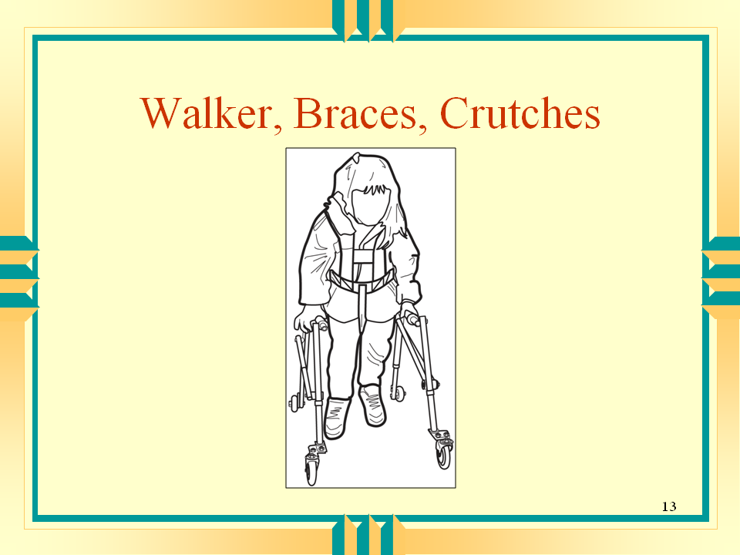
Group 2  - Tracheotomy tube  - IV or feeding tube  - Oxygen equipment | IV stands for intravenous. A feeding tube is also called a G-tube or gastrointestinal tube.  Show Slide 14.  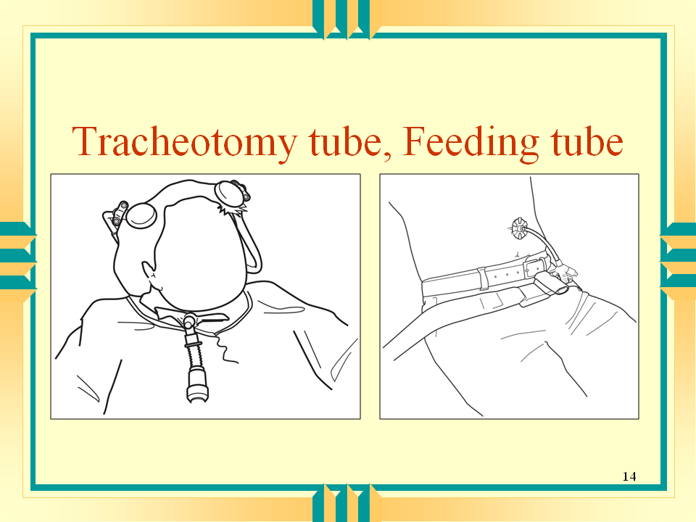
Other Equipment  - Conventional or special child safety seat or safety vest  - A guide dog  - Lap tray | Show Slides, 15, 16 and 17.  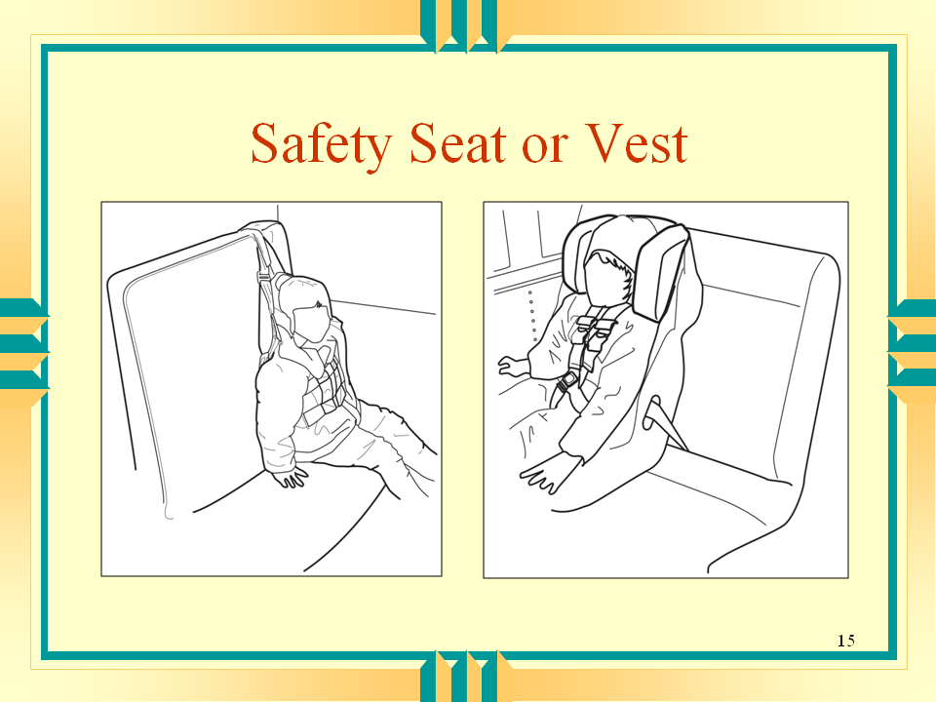
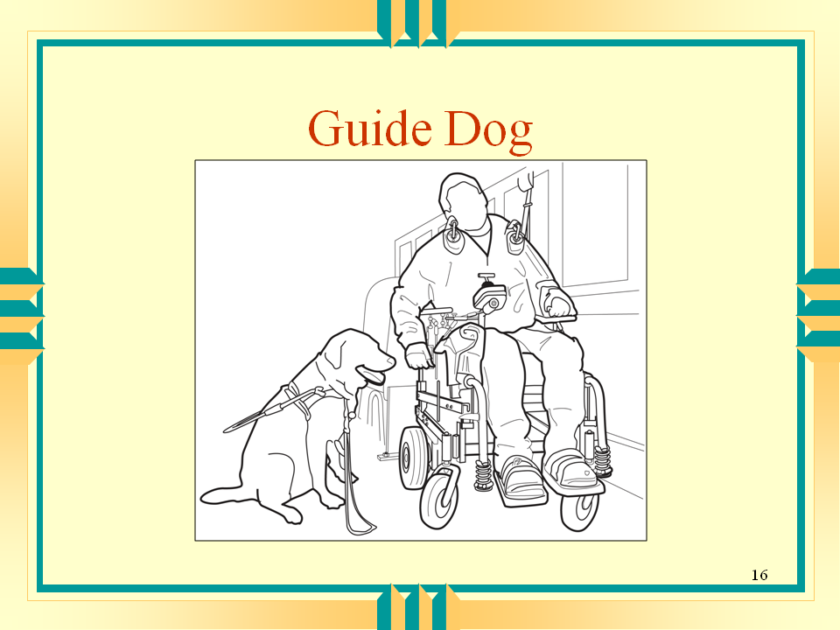

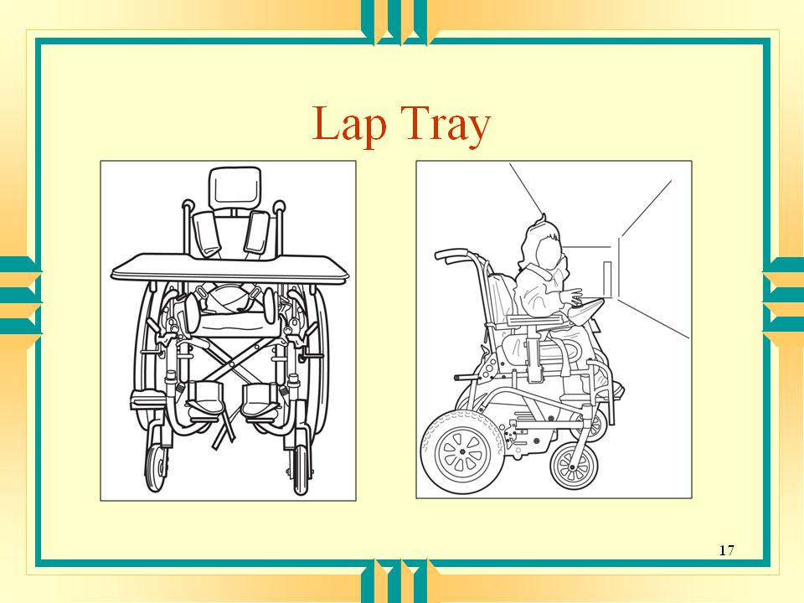
Ask: | Conduct discussion.  The school bus driver might encounter other specialized equipment or conditions. Two conditions that require special consideration during transport are the shunt and the spinal rod. If any of the participants have students with these devices, review the following information:  - Shunt  - Provide good head and neck support  - Make sure the shunted area is not bumped  - Make sure occupant restraint strap is not putting pressure on the shunt  - Spinal rod  - Student can’t sit in the back of the bus because of the bouncing  - Treat like a student with brittle bones
  Are there any other kinds of equipment that you have encountered?
Explain that some students have multiple disabilities and require several kinds of equipment.
Say that, because they are the most complicated, the focus of the discussion will be on wheelchairs and how to load and secure them.
- There are many kinds of wheelchairs.
- They range widely in cost from hundreds of dollars to tens of thousands of dollars.
- They have a variety of extra features.
- Here are some examples:  - Lap trays  - Tilt and recline options  - Various anterior chest supports  - Joysticks  - Different head and foot rests | Show Slide 18.  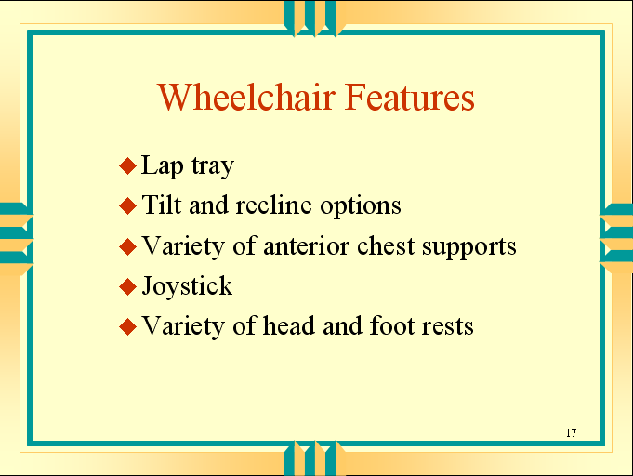
- Wheelchair Systems  - Some mobile seating devices are acceptable as safe seating during transportation.  - Some mobile seating devices the student cannot remain seated in during transportation.  - A wheelchair with a “sports” back  - A 3-wheeled scooter  - Be aware of:  - An extra heavy wheelchair that requires additional tie-downs  - The “tilt-in-space” wheelchair if tilted more than 20 degrees | Show Slide 19.  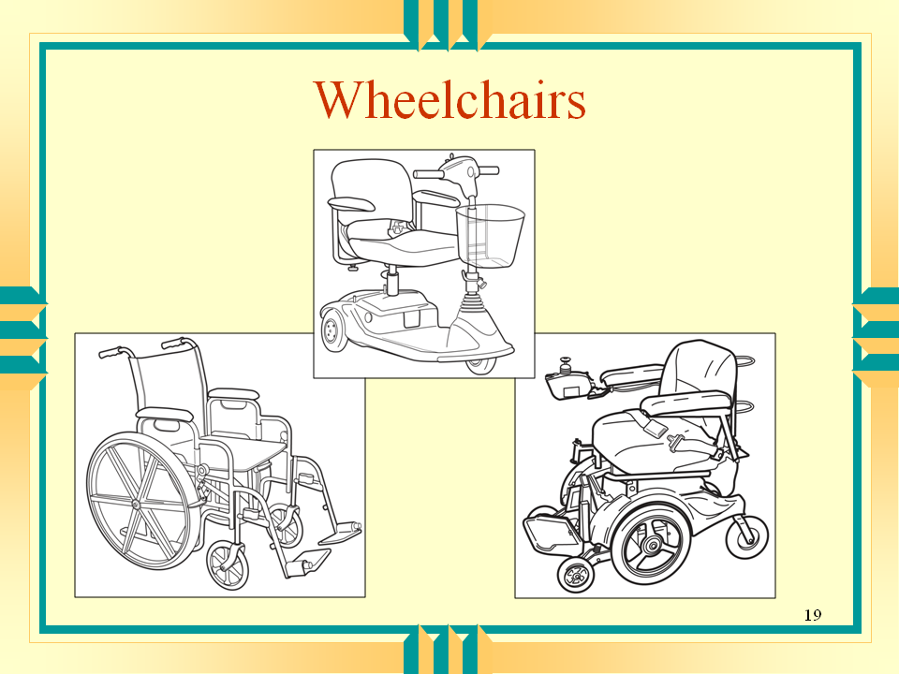  “Sports back” chairs do not have proper support for the head and trunk.  Three-wheeled scooters have a low shrouded base and a single pedestal seat. The seat has a tendency to crack off in an impact when occupied. It is also difficult to find suitable tie downs for these scooters.  Extra heavy wheelchairs are those with automatic recline and large computerized bases. They need additional securement to meet crash test standards because tie-downs are only tested up to 225 pounds.  If the “tilt-in-space” wheelchair is tilted more than 20 degrees, the shoulder belt won’t work correctly.
Explain that this doesn’t mean that students can’t use these wheelchair systems or strollers for loading purposes, but students should not be transported in them.
Tell participants that students using these chairs should be transferred to a regular seat in the school bus.
Explain that there is a standard for wheelchair crashworthiness.  - It is not a Federal standard.  - It is a voluntary standard.  - It was established by individuals, organizations, and transporters concerned about the safety of persons being transported while seated in wheelchairs.  - The purpose of the standard is to promote occupant safety and to reduce the risk of injury for motor vehicle occupants who remain seated in their wheelchairs during transit.  - A wheelchair that complies with this standard can be considered to provide a reasonable measure of safe and suitable seating during loading and unloading, during normal transportation, and in a frontal crash.  - However, it is still safer to sit in the seats provided by the vehicle manufacturer, whenever possible.  - This means transferring the student to a school bus seat. | Distribute Job Aid #4, Wheelchair Standard. Review it with participants.  The standard is ANSI/RESNA WC19. It was passed in May 2000. The complete standard can be found at http://www.wheelchairstandards.pitt.edu/WCS_T/WCS_T_RESNA/WCS_T_RESNA_SOWHAT/WCS_T_RESNA_SOWHAT_pdf/WCS_T_RESNA_SOWHAT_Stds_pdf/WC%2019%20Finaldraft%206%2099.pd . The official name is SECTION 19 ANSI/RESNA WC/VOL. 1 Wheelchairs for use in Motor Vehicles.

Lesson Plan | Instructor Notes
- This standard addresses:
- Wheelchair performance in a worst-case frontal impact test (for crash protection)
- The size and turning radius of the wheelchair (for ease in loading and unloading and in maneuvering inside the school bus)
- The lateral stability of the wheelchair (for comfort and security of the wheelchair user during transport)
- The preferable type of securement system, namely the 4-point, strap-type tie-down (the most common and effective securement system for the widest range of wheelchairs)
- The time required to secure and release the wheelchair (for easier and more rapid securement)
- The need for a wheelchair-anchored pelvic belt to which a vehicle-anchored shoulder belt can be readily connected (to achieve good fit and performance)
NOTE: There is a 2-year grace period for this requirement to allow manufacturers to modify existing product lines.
Review local policy on acceptable wheelchairs.
Ask:
Are there any questions about wheelchairs?

Storing and Securing Equipment
Tell participants that some equipment doesn’t have to be stored during transport because it stays attached to the wheelchair.
- For example:
- IVs
- Respirators
- Other suctioning or feeding tubes
- However, you must be sure that these devices are appropriately secured.
Ask: | Possible answers:  - Wheelchair (if the student is on a seat)  - Walker  - Lap trays  - Crutches  - Oxygen  - Other medical equipment  - Child safety seats
  What equipment will have to be secured?
General Rules for Storage  - Do not secure unattached equipment in these places:  - In aisles  - Where it would be a projectile  - In the evacuation path  - In a student’s lap  - Between the seat and the window | Show Slide 20.
- Lightweight items may be stored in cargo nets fixed to the side or back walls of the school bus.  - Other items may be secured:  - By seat belts in an unoccupied seat  - Under seats  - In latched compartments  - At the rear of the bus | Show Slide 21.
- Remember that all objects can become projectiles in a crash.
- ALL items must be stored properly
- This includes brooms and any other supplies or equipment you carry on the school bus
- Child safety seats must be secured or stored or go with the child.
- Either secured to the seat with or without the child
- Or stored in a storage area
- Or taken off the school bus with the child
Review local policy and procedures for storing equipment.

Service or Guide Dogs
Say that service or guide dogs on board a school bus may raise some issues.
- What do you do if another student is allergic to dogs?
- What do you do if another student is fearful of dogs?
- How do you secure the dog and keep it out of the way?
- Is the dog properly inoculated and certified?
- Will the dog respond to commands from the driver or attendant?
- How has the dog been trained to respond in emergencies?
- What training do transportation personnel and other students need?
Review local policy and procedures about guide dogs.

Equipment and Weather  Say that, finally, you need to talk about equipment and weather.  What kinds of weather can affect the equipment needed to transport students with special needs? | This section addresses non-emergency situations. Emergency situations will be addressed in the final section of this module.  For more information on weather- related emergencies, see the module, Driving Under Adverse Weather Conditions, School Bus Driver In-Service Safety Series.
Ask: | Possible answers:  - Ice  - Water (rain and snow)  - Temperature
  What kinds of weather can affect the equipment needed to transport students with special needs?
Say that equipment for both the school bus and for students can be affected by weather.
- Snow can make it difficult to lower the lift fully to the ground.
- Ice and snow can impair traction for both those in wheelchairs and those who are walking.
- Ice can make it difficult for motorized wheelchairs with electric motor controls to get off the lift.
- When it is very hot, buckles may become heated enough to burn the skin.
- Water can:
- Remove lubricating oil from parts
- Make seats wet
- Make school bus floor and steps slippery
- Snow with salt in it can dry on tie-down straps and make them stiff and difficult to use.
Explain that you need to have a plan for what you will do in situations where weather is affecting the safe transportation of students with special needs.
- Delay departure.
- Be sure to notify families if there will be a delay in pick up or drop off.
- Load or unload in a different place than in the designated location.
- Request assistance.

Review local policy and procedures for what to do in weather-related situations.
Ask: | Distribute Job Aid #5, Equipment and Assistive Devices in a School Bus. You may choose to review it with participants or tell participants to use it as a reference.
  Are there any questions about how to handle the equipment needed to transport students with special needs?

Lesson Plan | Instructor Notes
V. Loading and Unloading  Say that you have talked about the equipment used by a student with special needs. In particular, you have talked about wheelchairs. | 1 hour, 45 minutes  Show Slide 22.  Loading and unloading of specialized equipment needs to be practiced as specialized equipment has become quite complex. After presenting this section, you may want to have participants practice:  - Correctly using and operating the wheelchair lift  - Correctly loading and securing a wheelchair using the securement system in your school buses  - Correctly restraining a person using the lap and shoulder belts  - Securing and/or storing equipment, e.g., lap trays.
Tell participants that now you need to talk about loading and unloading.
Say that you will review:  - The proper loading and unloading process, including what to do and who should do it  - How to correctly use and operate a wheelchair lift  - How to use the 7-point wheelchair/occupant securement system  - The seating plan for your bus and what should be included in it | Show Slide 23.
Say that loading and unloading students with special needs requires more than one person.
Ask: | Ask the question and continue to probe until all of the members are listed.  Answers:  - School bus driver/attendant  - Parent or caregiver  - Teacher
  Who are the people who might be involved in the process?
Say that you will first talk about who is responsible for what. | Distribute Job Aid #6, Loading and Unloading. Review it with the participants.
- The School Bus Driver  - Loads the student onto the school bus at the site, both pick up and school.  - Unloads the student at the destination.  - Make sure that you know exactly who should receive the student in both places. | In some school districts, there is a monitor who is responsible for loading and unloading.

Lesson Plan | Instructor Notes
- Parent or Caregiver  - Before school, the parent or caregiver makes sure that the student is at the curb on time with or in the proper equipment.  - The parent or caregiver supervises the student until the school bus arrives.  - After school, the parent or caregiver meets the student at the curb on time.  - A parent or caregiver may want to help with loading.  - It is the ultimate responsibility of the school bus driver to recheck and make sure the wheelchair and the student are properly secured before moving the school bus. | Your policy may stipulate that the transfer of responsibility takes place at another place, e.g., the front door.  For instance, the parent might help the student onto the bus or fasten the seat belt or wheelchair positioning belt.  NOTE: A parent/caregiver’s responsibilities may be limited or required by local policy.
- Teacher  - Responsibilities are similar to those of the parent or caregiver.  - Meet the student upon arrival at school  - Have the student at the pick-up site on time and supervise the student until the school bus arrives. | This statement may not be true in your school district.
- Bus Attendant
- Sometimes another adult assists the school bus driver.
- These people may be called aides or attendants or monitors.
- The attendant may be assigned to help all students or one particular student.
- While on the bus, the attendant is usually under the authority of the school bus driver.
- The attendant’s responsibilities should be noted in local policy.
Review local policy and procedures about who is responsible for what during the loading and unloading process.

Loading and Unloading Process for Walkers
Review the loading and unloading process for walkers.
- Stand behind the student who is getting onto the bus.
- Stand in front of the student who is getting off the bus.

Lesson Plan | Instructor Notes
Loading and Unloading Process for Wheelchairs  Review the loading and unloading process for wheelchairs.  - There is generally a comprehensive local policy for loading and unloading student with special needs.  - This policy should lay out guidelines to follow when loading students using specialized equipment. | Occasionally a student with special needs has unique requirements that must be addressed during the loading and unloading process. That student should have a separate loading procedure described in his or her IEP. This loading procedure will describe:  - What the student will do for himself or herself and what the school bus driver needs to help with  - What specialized equipment will be used during the loading process and when
Say that, before you get into the procedure for loading with a wheelchair lift, you want to review about what participants should know about wheelchair lifts. | Tell participants that you will review how to load and unload students in the next section. This section focuses on the operation of the lift.
Wheelchair Lifts  - Wheelchair lifts come in several varieties.  - You need to become familiar with the lift on your school bus and how it works.  - Remember to follow the manufacturer’s instructions for the wheelchair lift on your school bus.  - If you don’t have the instructions, ask for them. | Distribute Job Aid #7, The Wheelchair Lift. Review it with participants.

Lesson Plan | Instructor Notes
- Whatever the type, wheelchair lifts have similar components.  - Platform  - Outboard roll stop  - Inboard roll stop  - Hand rails  - Vertical arms  - Top and bottom parallel arms  - Base plate  - Hydraulic pump with manual backup | Review the diagram and the parts of the lift. If your lift operation differs from that presented in the instruction, review the operation of the lift on your school buses.
- There are several safety features on the wheelchair lift.
- The outboard roll stop is activated by the up and down buttons.
- When the up button is pushed, the outboard roll stop rotates to the vertical position before the platform rises.
- When the down button is pushed, the outboard roll stop does not rotate to the horizontal position until the platform is lowered fully to the ground.
- The inboard roll stop position is also activated by the up and down buttons.
- When the down button is pushed, the inboard roll stop rotates to a vertical position.
- It remains in the vertical position while the wheelchair is loaded or unloaded on the ground.
- When the up button is pushed, the inboard roll stop rotates to the horizontal position when the platform reaches the vehicle floor level.
- The bridge plate rotates to the horizontal position when the unfold button is pushed
- It rotates to the vertical position when the fold button is pushed
- Interlock devices prevent operation of the lift or the school bus when it is not safe
- Interlock devices can work in a variety of ways
- Locks the school bus transmission in place when the lift is deployed
- Doesn’t allow the lift to be deployed until the school bus is in PARK and the emergency brake is set
- Stalls the school bus engine if the lift is deployed and the emergency brake is released or the transmission is shifted from PARK.
- Discontinue operation immediately if any of these safety features do not work properly.

School Bus Position
- Before using the wheelchair lift, park the vehicle on level ground
- Do not park on a slope.
- Remember that the platform must rest completely on the ground.
- Choose a place to load without obstacles to interfere with the operation of the lift.
- Review the operation of the interlock device on your school buses.

Who Can Use a Wheelchair Lift?
- Wheelchair lifts are designed to be used by:
- Anyone using a wheelchair or other mobility aid
- Due to liability, schools should never have someone stand on a lift.
- Carry in the school bus a loaner wheelchair or a stroller for lift use.
- Wheelchair lifts have a capacity of 800 pounds.
- Lift attendants should not ride on the platform with the passenger.

Emergency Situations
- If you experience a power or equipment failure and you have a child on the lift, you can operate the lift manually.
- Review the manufacturer’s instructions for operating the wheelchair lift on your bus manually.

Procedure for Loading With a Wheelchair Lift
- Remember to tell the student what you are going to do before you do it.
- Open and secure the lift door.
- Use the hand-held control to activate the unfolding of the platform.
- Lower the platform until it rests entirely on the ground.
- Unfold the outboard roll stop.
- Fasten the wheelchair seat belt around the student. Be sure the wheelchair seat belt is in place.
- Back the student onto the lift.
- Always face the student away from the school bus.
- NOTE: To unload a student with a motorized wheelchair
- The student should NOT drive onto the lift unless cleared to do so by the entire IEP team.
- Disengage the motor and push the chair onto the platform manually.
- Consult with a parent/caregiver or a therapist about how to secure the chair on the lift.
- Lock the wheelchair brakes.
- Turn off the wheelchair power.
- In some cases, the motor must be disengaged to secure the wheelchair.
- Ask the parent/caregiver or therapist for guidance.
- Make sure the roll stops are in the completely “up” position.
- Have the student hold onto the handrails if able.
- Tell the student to keep arms and legs within the lift area and clear of moving parts.
- Operate the lift controls.
- Stand next to the platform at the front corner.
- Keep one hand on the wheelchair as it is raised and operate the controls with the other hand.
- When the platform reaches floor level, set down or hang up the controls.
- Release the wheelchair brakes and push the wheelchair into the bus.
- Set the wheelchair brakes.
- Fold the lift into the travel position.
- Position the student according to the IEP.  - The IEP should specify whether to transfer the student to a regular forward facing school bus seat.  - Or whether to secure the wheelchair and the student.  - Review local policy and procedures for the use of wheelchair lifts. | Refer participants to Job Aid #8, Emergency Situations, for proper lifting techniques.
Remind drivers that some wheelchairs are not suitable for transporting students in vehicles.
- Lightweight sports chair with low back
- 3-wheeled scooter
- Cart
- Stroller
- Chair with battery high on the back
- Positioning chair
Say that students with these chairs must be moved into regular school bus seats.

Guidelines for Securing Wheelchairs
Say that many school buses used to transport students with special needs have a wheelchair securement system.
- The securement system is a way to tie down or anchor a wheelchair to the school bus.
- The securement system must be used whenever the school bus is not parked.
- Federal Motor Vehicle Safety Standard (FMVSS) 222 has specific requirements for the wheelchair securement and occupant restraint system.
- The wheelchair securement positions must be forward-facing.
- The anchorages for the wheelchair and occupant restraint and the securement and restraint devices must be of minimum strengths.
- There must be 4 tie-down devices for each wheelchair.
- There must be lap and shoulder belts for each wheelchair location.
- FMVSS 222 requires 7 points for a securement system:
- A 4-point system to anchor the wheelchair to the vehicle
- A 3-point system to attach the occupant to the wheelchair (some wheelchairs have their own seat belt, some need one in vehicle)
- The shoulder belt must be attached to the vehicle.
- The lap belt can be attached to the wheelchair 4-point anchor system or to the vehicle.
- If the lap belt is attached to the wheelchair, it must meet Federal requirements. Such belts are only found on wheelchairs meeting the ANSI/RESNA Wheelchair-19 Standard
Remind drivers that there is a difference between the seat belt (used for occupant restraint) and a postural aid or pelvic belt (used to hold in or to hold erect a student with a particular disability).
Say that FMVSS 222 requires that the wheelchair in a school bus be forward-facing; there are several reasons why this makes sense.
- The securement system is designed to be used with the wheelchair facing forward and is tested that way.
- All new school buses manufactured with wheelchair securement systems since January 1994 have forward-facing systems.
- There are several reasons why forward-facing is preferred.
- Most sudden stops are in a forward direction and most crashes are frontal.
- In emergency stopping situations, the student is thrust in the direction that the school bus is traveling.
- The student will bend forward, rather than sideways.
- The human body is designed to bend forward easier than sideways so the risk of serious injury is reduced.
- Side-facing requires more energy to maintain balance and position.
- Wheelchairs are designed for maximum frontal force.
- In a sideways force (when the wheelchair is facing sideways) the spokes of the wheel facing the front of the school bus may collapse
- Visually induced seizures may be made worse when the student faces side windows.
Where to Anchor the Wheelchair  - The securement can be a metal locking unit or a webbing belt system.  - Cautions  - Do not jerry-rig a securement for a wheelchair.  - Only use an approved 4-point tie-down system. At a minimum, the front straps must be the same type and the back straps must be the same type.  - Don’t interchange systems. Use only one manufacturer’s tie-down system for each wheelchair. | Remember proper body mechanics and lifting techniques when attaching the straps. Bend at the knees, not at the waist. Refer participants to Job Aid #8, Emergency Situations, for proper lifting techniques.  Some drivers/attendants wear knee pads to be more comfortable when anchoring wheelchairs.  For example, you must not use a quick release strap AND a ratchet strap on the front, although you could use 2 quick release straps or 2 ratchet straps.

Procedure for Securing the Wheelchair
- First, follow the manufacturer’s guidelines for that particular wheelchair and for your system.
- If you don’t have the manufacturer’s instructions, ask for them.
- Center the wheelchair with the anchorages on the floor.
- Leave room for the rear belt to be secured at a 45-degree angle from the floor.
- Set the wheelchair brakes on both sides; turn off the wheelchair power.
- Attach the wheelchair straps to the wheelchair at 4 points.
- Attach the straps along the wall first.
- Then attach the straps along the aisle.

Lesson Plan | Instructor Notes
- Attach the straps properly.
- Do not attach the straps to the wheels or any detachable portion of the wheelchair.
- Don’t let the straps bend around any object. They should have a clear path from the floor to the wheelchair frame.
- Keep the straps away from sharp edges or corners.
- Do not criss-cross or twist the straps.
- FMVSS 222 requirements: Make sure that the belts are at a 30 to 60-degree angle; a 45-degree angle is the best.
- Never use the 4-point system without also using the 3-point lap and shoulder belt.
- Make sure that the wheelchair doesn’t have forward or reverse movement.
- If you can’t get the wheelchair attached properly, contact dispatch.
Review local policy and procedures on the use of wheelchair securement systems.

Procedure for Securing the Student
- Whenever you secure a wheelchair with a student in it, you must also use a 3-point system to secure the student.
- The wheelchair securement doesn’t hold the student in the wheelchair.
- The occupant restraint system is separate from the wheelchair securement.
- The 3-point system secures the student’s pelvis and torso.
- The occupant restraint system can be attached in several ways.
- To the school bus anchorage points
- To the wheelchair securement system
- To the wheelchair itself only if the wheelchair meets ANSI/RESNA Wheelchair - 19 Standard
- Whatever system is used, follow the manufacturer’s instructions.
- General guidelines:
- Position the lap belt over the pelvic bones, not the abdomen.
- Position the lap belt inside the arm rests between the side panels and the cushion.
- Adjust the belt so it is snug.
- Position the shoulder belt so it does not cross the student’s face or neck.
- Never position the shoulder belt under the student’s arm where is would cross the rib cage.
- Adjust the shoulder belt to achieve firm but comfortable tension.
- Never twist the belts; the belts should always lay flat against the body.
Review local policy and procedures.
Ask:
Are there any questions about securing the wheelchair or the student?

Placement of Students

Say that where you seat the students on your school bus should not be haphazard.

Explain that you should think about and lay out a seating plan for your school bus.
Ask: | Possible answers:  - Your route and the order in which students are loaded and unloaded at home and at school  - The medical conditions of the students  - Evacuation  - Behavior  - Supervision  - The age of the student  - Your ability to observe the student
  What are some things to consider when developing a seating plan?
Say that, when considering medical conditions, think about:
- Students who are medically complex or vulnerable and who need to sit further front where there is less bounce
- Students who are prone to seizures should not be in certain light conditions
- Younger students and those in child safety seats who need to sit in the first few seats
- Students with respiratory conditions who need to sit away from the lift area and away from rear windows near the exhaust. Changes in temperature also tend to bother these students.
- Students who may need to sit over wheel wells for additional lower extremity support
Say that, when considering evacuation, think about:
- Which students can evacuate themselves?
- Which students need help?
- Which students could help others?
- Which students are in child safety restraint systems?
- They should not be in emergency exit rows.
- They should not be in aisle seats with students who are unrestrained seated in the window seats.
- Think about which students are compatible and which aren’t.
- Think about who needs supervision either for behavior or for a medical condition.
- Put your plan in writing.
- This will be especially helpful for a substitute.
Review local policy and procedures about student seating.

Safe Stopping Places
Say that, in addition to having a seating plan, you need to have a plan for exactly where to stop the bus to load each student. When developing your loading plan, you need to consider:
- Where to stop the school bus so the wheelchair lift operates properly
- Where to stop so that you can be seen by other traffic
- How and when to use the warning systems  - School buses have warning systems that are activated and deactivated during the loading and unloading process.  - These warning systems affect traffic flow. | Discuss what discretion the school bus driver has in using warning systems. Although they need to consider the safety of the students, they also have to consider the traffic that might be halted while they unload.
Review local policy and procedures about the use of warning systems.
- Where to stop the bus if the original site is not available
Review local policy and procedures on safe stopping places.
Review any other local law, state law, and local policy and procedures on loading and unloading that have not been covered.
VI. Emergency Situations  Say that you have talked about loading and unloading in normal situations. You also need to talk about what to do in emergency situations. | 1 hour  Show Slide 24.  After presenting this section, you may want to have participants practice:  - The one-person lift  - The 2-person lift  - The blanket drag.  REMINDER: This is not a review of general evacuation procedures. This section reviews emergency situations with students with special needs.
Tell drivers that, in this section, we are going to talk about:  - The kinds of emergencies to expect as a school bus driver of students with special needs  - What needs to be included in an emergency evacuation plan  - How to handle an emergency on the school bus | Show Slide 25.
Ask: | Possible answers:  1. With the vehicle  - The school bus breaks down  - The lift won’t work  - A crash  - A fire on the bus  2. With the driver  - Driver illness  3. With a student  - Medical problem  - An equipment problem  - DNR orders  4. Weather or external emergency  - Not being able to stop or unload where you are supposed to  - Something life threatening (fire, flood, tornado)]
  What kinds of emergencies might you have on a school bus with students with special needs?
Explain that, for some of these problems, drivers will have to evacuate the school bus; for others they won’t have to evacuate.  - In general, if the situation is not life-threatening, you probably don’t have to evacuate.  - For example, a medical problem with one of the students probably doesn’t require evacuation of the whole school bus.  - A broken lift doesn’t require evacuation. | Distribute Job Aid #8, Emergency Situations. See next page. Review it with the participants.

Lesson Plan | Instructor Notes
- However, if the situation is life-threatening, you may have to evacuate
- If the threat is from something on the school bus, get off the school bus.
- If the threat is from something outside the school bus, ask yourself:
- Will the students be safer outside that on the school bus?
- Can I get them out fast enough?
Review local evacuation policy.

Develop an Evacuation Plan
Say that every school bus driver should have an evacuation plan for the school bus. School bus drivers who have students with special needs need to think about how to evacuate those students.
Talk about what needs to be considered when preparing the evacuation plan:
- The students’ ability
- Which students can come off the school bus by themselves?
- Which students can be removed from the bus without their wheelchair (or specialized seat or child safety seat)?
- Which students must not be removed from their wheelchair (or specialized seat or child safety seat)?

Lesson Plan | Instructor Notes
- Which students have essential equipment that also must be removed?
- What equipment do you need for an evacuation?
- At a minimum you need a belt cutter or rescue knife and a fire blanket.

Belt cutter/rescue knife
- This special knife consists of a narrow slot with a blade at the end of the slot.
- It can cut seat belts and tie-down straps.
- The belt is fit into the slot and cuts with one motion.
- Store the belt cutter in a location that is easily accessible but that the students can’t reach.

Fire blanket
- To smother fires
- For hypothermia
- For the emergency evacuation of medically complex or heavy students
- What personnel will be available to help you?
- In addition, which students can help others get off the school bus?
- Where are emergency services along your route?
- Fire stations
- Hospitals
- Police
- Clinics
Say that the written evacuation plan should include:
- A diagram of the seating pattern that identifies which student sits where
- Information on how to evacuate each student
- The location of emergency evacuation equipment
- Order in which to evacuate the students
Review local policy and procedures on emergency evacuation plans.

General Emergency Guidelines
Say that there are some general rules for how to handle an emergency.
- Stay calm.
- Students may panic and become uncontrollable if they sense fear and anxiety.
- Stop as soon as possible in a safe place.
- Off the traveled roadway, preferably in a parking lot or driveway.
- Secure the vehicle.
- Put the transmission in PARK.
- Set the emergency brake.
- Turn off the ignition.
- Take the keys.
- Contact dispatch.
- Report the emergency.
- Ask for help (e.g., medical assistance, another vehicle).
- If appropriate, use warning devices to prevent an additional emergency.
- If you decide to evacuate:
- Explain what you are doing using simple, concise directions:
  - To the students
  - To outside help if you need to enlist it
- Use all doors if possible.
- Once students are off the school bus, move them to a safe place away from the school bus.
Review local emergency procedures.
Say that there are several techniques you may need to know to get students with special needs out of the school bus in an emergency. These techniques are:  - The one-person lift  - The 2-person lift  - The blanket drag | It would be good to have some assistance in teaching this section. Before class, arrange for 2 other people to demonstrate these techniques. You might also be able to arrange for a dummy or a weight representing a child to be lifted. As you go through the general lifting guidelines as well as the one-person lift, the 2-person lift, and the blanket drag, the other person or people could demonstrate what you are describing.
General lifting guidelines  - Never lift anyone more than half your weight  - Ask for help if you are unsure  - Test your lifting ability with a small movement that can be stopped  - If the student weighs too much, use another method | There are several excellent state manuals that provide more detail on techniques for evacuating students with special needs from a school bus. Contact your State Director of Pupil Transportation.

Lifting Process
  - Clear the path to the exit.
  - Tell the student exactly what you are going to do before you do it.
  - If necessary, cut the seat belt and other positioning straps
  - Stand balanced with your feet shoulder width apart.
- Face the student.
- Face in the direction you want to go, if possible.
  - Get a good grip on the student or the student’s clothing; use your palms, not just your fingers.
  - Squat down but keep your heels off the floor.
  - Get as close to the student as you can.
  - Lift gradually (without jerking) using your leg, abdominal, and buttock muscles.
  - Keep the student as close to you as possible.
  - Keep your chin tucked in so as to keep a relatively straight back and neck line.
  - Once you're standing, change directions by pointing your feet in the direction you want to go and turning your whole body.
  - Avoid twisting at your waist while carrying a student.
  - Take small steps, keeping the student close to your body.
  - With students with poor muscle control.
- Curl the student as much as possible to keep the student’s arms and legs from flopping.
- Support the student’s head and neck.

One-person lift
- Follow general lifting guidelines.
- Pass the student’s near arm over your shoulder.
- Place one of your arms behind the student’s shoulders with your hand under the student’s other arm.
- Place your other arm under the student’s knees.
- Squat down with feet shoulder width apart.
- Lift the student with the load equally divided between both arms, holding the student close to you.

Two-person lift
- Follow general lifting guidelines.
- Move the student in a wheelchair as close to the exit as possible.
- Slide the student on a seat next to the aisle.
- The taller person stands behind the student and the other person stands in front of the student and off to the side.

Lesson Plan | Instructor Notes
- The person in back reaches under the student’s arms and:
  - Either grasps right hand to student’s right wrist and left hand to student’s left wrist
  - Or clasps hands across the student’s chest
- The person in front lifts the lower extremities under the thighs and hips.
- Squat down and lift together on a count of 3.
- Move to the designated area and lower the student on the count of 3.

Blanket drag
Explain that using a blanket reduces stress on the student’s body and the chance of injury.
Say that the blanket drag is also a way to move heavier students or fragile students who might be hurt by lifting.
Caution participants, however, the blanket drag is not a good choice for students who are medically fragile.
- Process:
  - Follow general lifting guidelines.
  - Fold a blanket in half and place in on the floor next to the student.
  - Lower the student’s legs onto the blanket first, then the head.
  - Place the student with his head toward the exit.
  - Wrap the blanket around the student to prevent arms and legs from being caught on obstacles.
  - Grasp the blanket near the student’s head and drag the student to the exit.
Remind drivers that the lift can be operated manually.
Refer to the manufacturer’s instructions for the correct procedure for your lift.
Explain that all of these emergency precautions have to be practiced. It is not enough for you, the school bus driver, to know what you will do in an emergency.
- The students must know, too
Tell drivers that they must conduct regular evacuations drills:
- Conduct the same number that you would with non-disabled students.
- Consider the special circumstances of the students on your bus. Some may not be able to participate in drills fully. However the procedure must be explained to them.
- Consult with the Occupational and Physical Therapists working with the students.
- Consult the IEP team about a student’s ability to participate.
Review local policy and procedures on evacuation drills.

